**Loop identification**

This optimizations identifies loop in a given CFG (control flow graph)

Execution: for gui just execute the program

For command line execution run in the following way:

CompilationLoopIdentifications [inputfile.vcg]

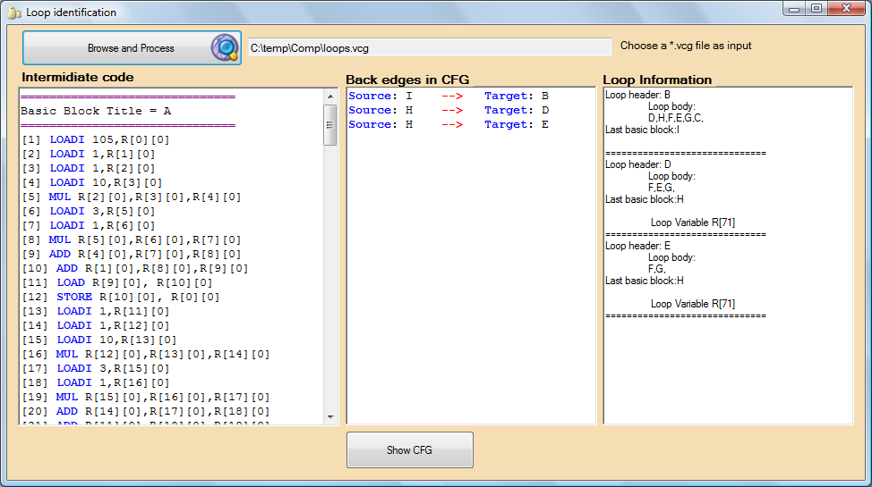

Input: vcg file (this file type is output of create basic blocks stage in the pascal++ workspace)

Output: Displays to screen the loops in the cfg and produce an xml called loops.xml

XML format

<?xml version="1.0" encoding="utf-8" ?>

<LOOP_IDENTIFICATION_FOR_COMPILER_LAB_ORT_BRAUDE>

<LOOP_LIST>

<LOOP>

<FIRST_BASIC_BLOCK>**A**</FIRST_BASIC_BLOCK>

<LOOP_BODY />

<LAST_BASIC_BLOCK>**B**</LAST_BASIC_BLOCK>

<LOOP_ITERATION_VARIABLE />

</LOOP>

</LOOP_LIST>

</LOOP_IDENTIFICATION_FOR_COMPILER_LAB_ORT_BRAUDE>